E-Bikes vs. Mopeds/Scooters

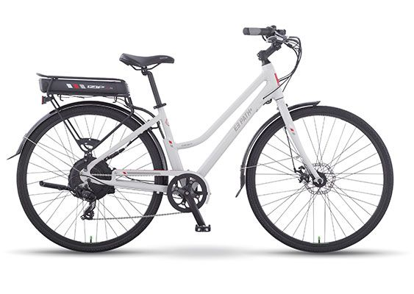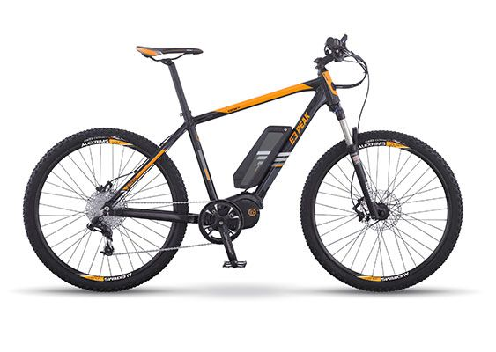
 ✔  Meets C.P.S.C. E-Bike Definition ✔  Meets C.P.S.C. E-Bike Definition

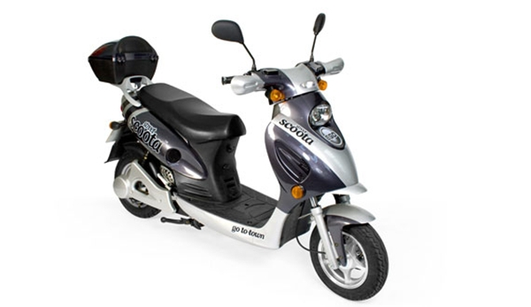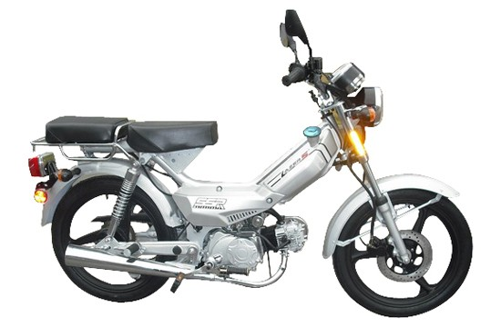

✖ Not Federal C.P.S.C. Compliant ✖ Not Federal C.P.S.C. Compliant

